**Bell Ringer**: Enzyme Activity

*AP Biology*

**Describe the differences between these two different images.**

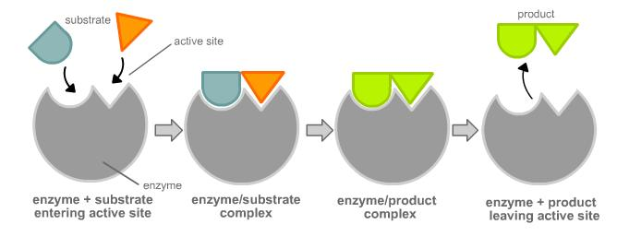

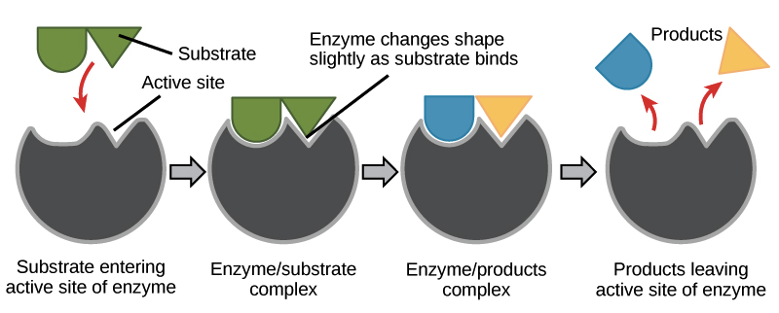

**Bell Ringer**: Enzyme Activity

*AP Biology*

**Describe the differences between these two different images.**



